**Project Design Phase-II**

**Data Flow Diagram & User Stories**

|  |  |
| --- | --- |
| Date | 20 October 2022 |
| Team ID | PNT2022TMID03606 |
| Project Name | Project - Real-Time River Water Quality Monitoring and Control System |

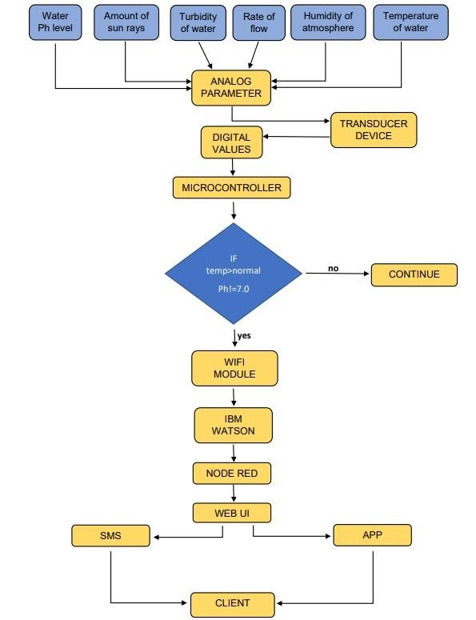**Data Flow Diagrams:**

**User Stories**

|  |  |  |  |  |  |  |
| --- | --- | --- | --- | --- | --- | --- |
| **User Type** | **Functional**  **Requirement (Epic)** | **User Story**  **Number** | **User Story / Task** | **Acceptance criteria** | **Priority** | **Release** |
| Customer  (Mobile user) | Registration | USN-1 | As a user, I can register for the application by entering my email, password, and confirming my password in the app created. | I can access my account / dashboard | High | Sprint-1 |
|  |  | USN-2 | As a user, I will receive confirmation email once I have registered for the app & access the application | I can receive confirmation email & click confirm | High | Sprint-1 |
|  |  | USN-3 | As a user, I can register for the application through Facebook, Gmail & Mobile number | I can register & access the dashboard with Facebook Login | High | Sprint-2 |
|  | Login | USN-4 | As a user, I can log into the application by entering email & password |  | High | Sprint-1 |
|  | Dashboard | USN-5 | As a user I will be updated by the app for interval of every minute by the spontaneous network system. |  | High | Sprint-2 |